# **MOTHER INDIA ANNUAL**

**EXAMINATION**

**CLASS – X**

**DATE – 04.02.2022 SUBJECT – SCIENCE FM – 40**

**SESSION – 2021-2022 TIME – 2 HRS**

**________________________________________________________________**

**General Instructions:**

1. All questions are compulsory.
2. The question paper has **three sections** and **15 questions**. All questions are compulsory.
3. Section–A has 7 questions of 2 marks each; Section–B has 6 questions of 3 marks each; and Section–C has 2 case based questions of 4 marks each.
4. Internal choices have been provided in some questions. A student has to attempt only one of the alternatives in such questions.

# ________________________________________________________________

## SECTION – A

**1.** a) Draw the structure of benzene molecule.

b) Explain why carbon generally forms compounds by covalent bonds. **2**

**2.** An element X has atomic number 13.

1. Write the electronic configuration.
2. State the group to which X belong.
3. Is X a metal or nonmetal?
4. Write the formula of its bromide.  **2**

**3.** a) Why is ozone layer getting depleted at higher levels of the atmosphere?

b) How it is important for the existence of life? **2**

1. Pesticides are non biodegradable chemicals so get accumulated at each tropic level. In the following food chain which organism will have maximum concentration of pesticides? Why?

Grass  mice  snake  hawk **2**

1. A filamentous algae X growing in fresh water simply breaks into two or more pisces to grow into a new filamentous algae. a) Name this algae X.

b) What is the method of forming a new filamentous algae known as?

**OR** **2**

A worm X found in fresh water streams cut accidentally into three pieces. In due course of time each cut piece of the worm develops to form a new worm. a) Name the worm which can exhibit this phenomenon.

b) What is the name of the process in which a complete organism is formed from its cut body parts.

**6.**

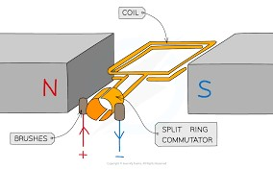

1. Which rule need to apply to find out the direction rotation of coil?
2. What type of energy conversion is occurring in the above arrangement?

**OR 2**

1. How strength of magnetic field can be represented by magnetic lines of force?
2. In a circular current carrying loop having clockwise current, the direction of magnetic field is toward the centre of the circle. Which rule helps to determine that?

**7.** Ovaries are the primary reproductive organs in a female.

1. What is the location of this organ?
2. Name the hormones secreted from it.

**OR**  **2**

A black eyed man married a brown eyed woman. All children born are with black eyed.

Why this occurred? Differentiate between phenotype and genotype.

## SECTION – B

**8.** a) State modern periodic law.

1. Which is bigger, N or P and why?
2. How does the metallic character of elements change along a period of the periodic table

from left to right and why? **3**

**9.** a) What is homologous series?

1. Draw the structure of an alcohol with three carbon atoms in the molecule.
2. Draw the electron dot structure of ethene and ethyne.

**OR**   **3**

1. Draw the structural isomers with the molecular formula C4H10.
2. Name the functional group present in the following compound

CH3CHO, CH3COCH3

1. What is catenation?
2. Study the following food chain.

Grass  grasshopper  frog  snake  peacock.

If in this chain 2000J of energy is available at producer level i.e. to the grass then calculate

the energy transferred to the peacock as food.  **3**

1. a) A bulb consumes 360 Kwh energy in the month of January. What change in filament should be done to make it 240 Kwh with the same power supply?

b) Cost of 1 Kwh is 18 rupees. Calculate the cost of 100 J. **3**

**12.**

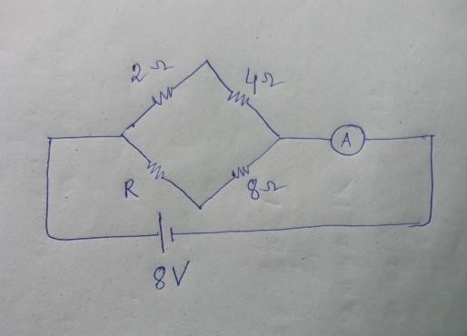

In the above circuit, if the current reading in the ammeter A is 2A, what would be the value of R?

### OR 3

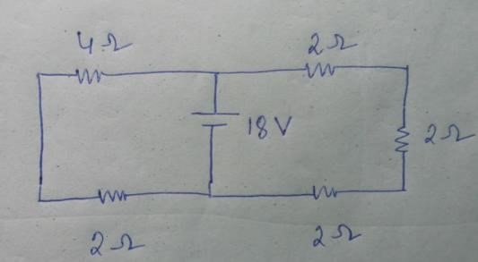

Calculate the current through 4 ohm and the total resistance of the circuit.

**13.** A flask shaped organ X in the centre of a flower has three parts.

1. Identify the structure X.
2. State the three parts of it and write their function. **3**

## SECTION – C

**14.** Rina in an experiment crossed a tall yellow seeded pea plant (TTYY) with a dwarf green seeded pea plant (ttyy).

1. Find out the type of plant obtained in F1 generation.
2. What are the various genotypes obtained in F2 generation when F1 plants are self pollinated. (Show in a punett square)
3. Write the phenotypic ratio in F2 generation.

**OR**  **4**

Rohit crossed a Round seeded pea plant (RR) with a wrinkled seeded pea plant (rr). Two F1 plants were crossed and F2 generation was obtained.

1. What type of seeds will be found in F1 generation? Why?
2. Differentiate between dominant and recessive trait.
3. Write the phenotypic and genotypic ratio of F2 generation.

**15.**

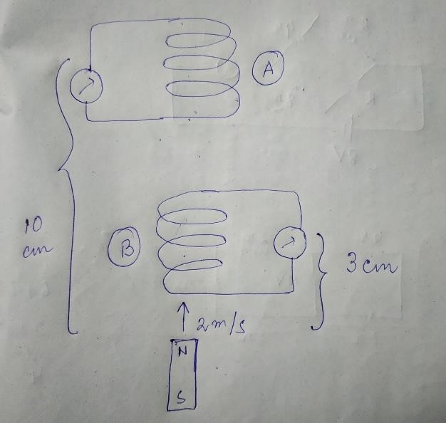

A magnet with initial speed 2m/s is thrown in upward direction in such a way that it passes through two coils A and B kept at a height 10cm and 3cm respectively shown in the figure above. a) What will happen when the magnet is thrown upward direction?

1. Will there be any change in galvanometer when the magnet returning back through the coils in downward direction?
2. Will the induced current in coil be maximum? Justify your answer.

### OR 4

What type of energy conversion is occurring here? Give one example where the reverse energy conversion is occurring.